Spring REST using Spring Boot3
Create a Spring Web Project using Maven

- Created and configured a Spring Maven Project – “spring-learn” with Spring Web and Devtools dependencies.
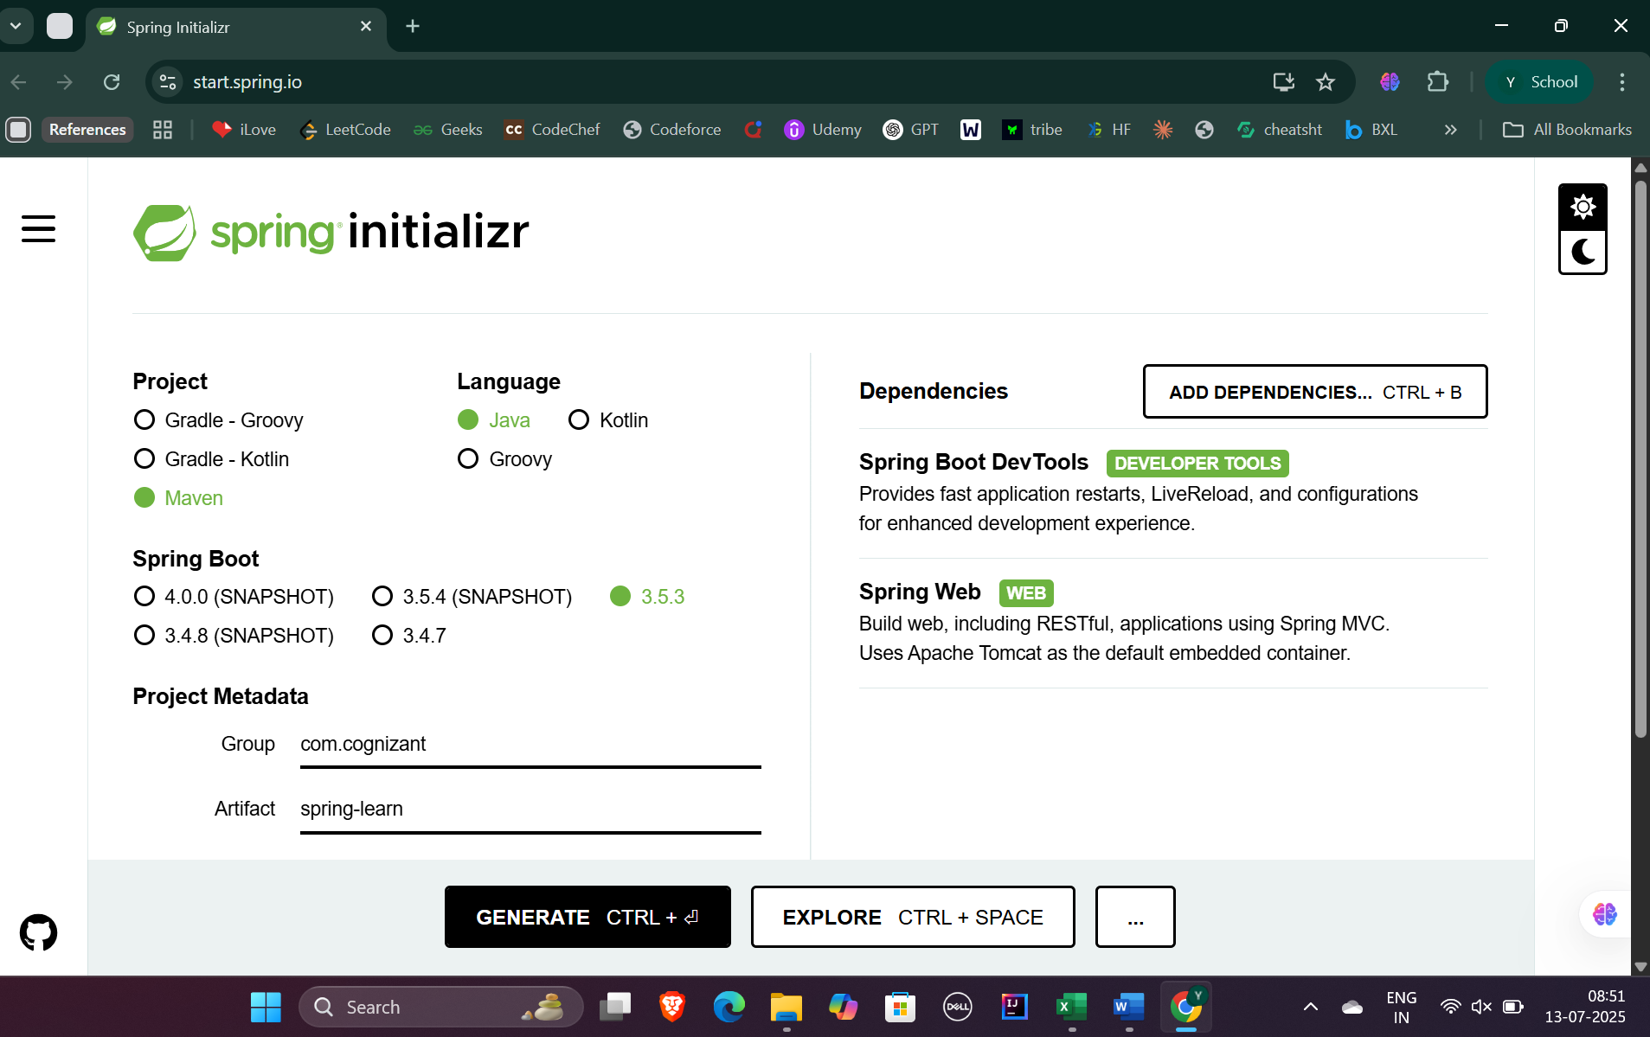
- Built project using proxy settings and mvn clean package .
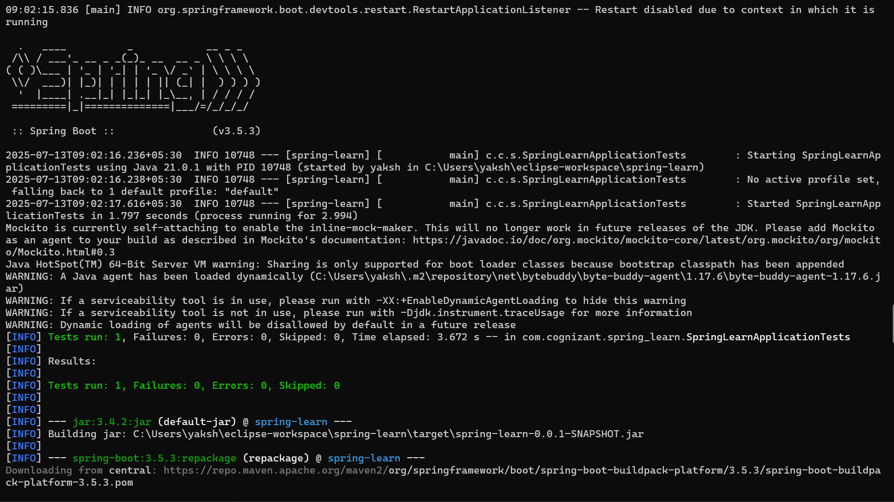
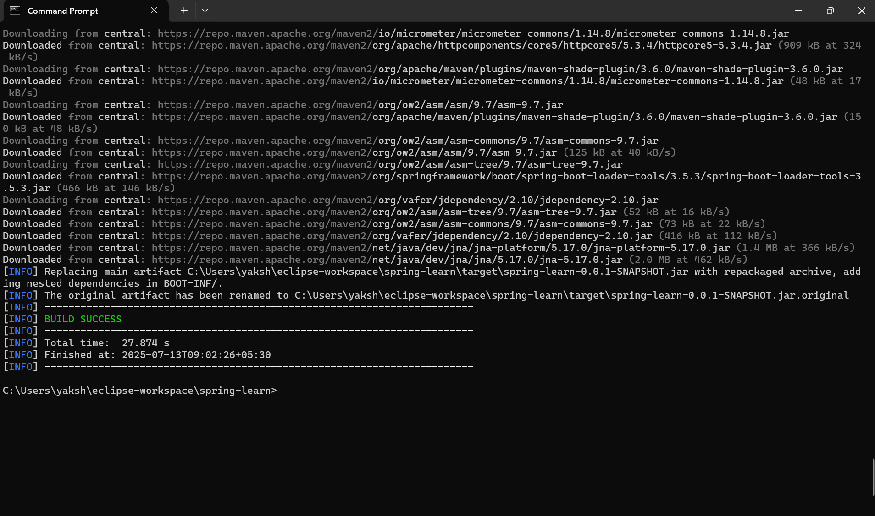

- Imported project to Eclipse
  - Added Logging in main() method.
  - Ran the spring application and got the log output – “ Application started successfully”
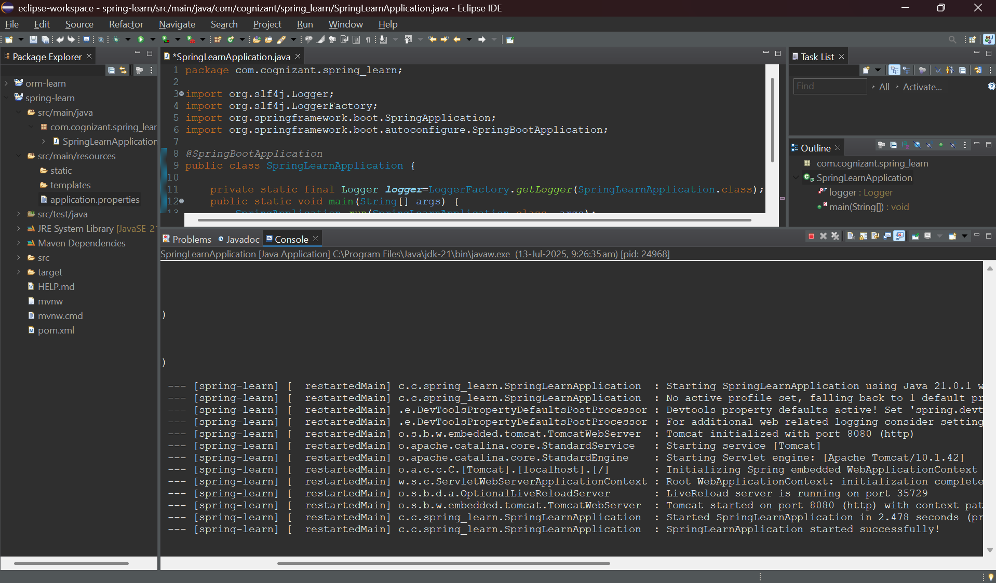

SME Walkthrough :
Purpose of each folder within project :
- Main/java – contains source code , main class of the Spring Boot app.
- Main/resources – contains configuration files like application.properties , static/ (for web assets) , templates/ (for thymeleaf templates)
- Test/java – holds unit and integration testcases (if any)
@SpringBootApplication serves as entry point for Spring Boot.
Opening pom.xml and clicking on Dependency Hierarchy gives a tree structure and shows transitive dependencies along with their versions.

